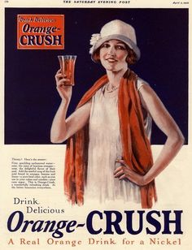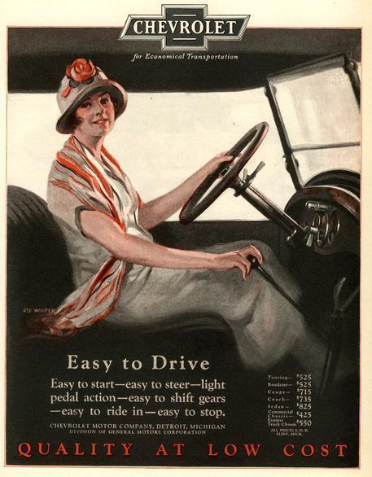

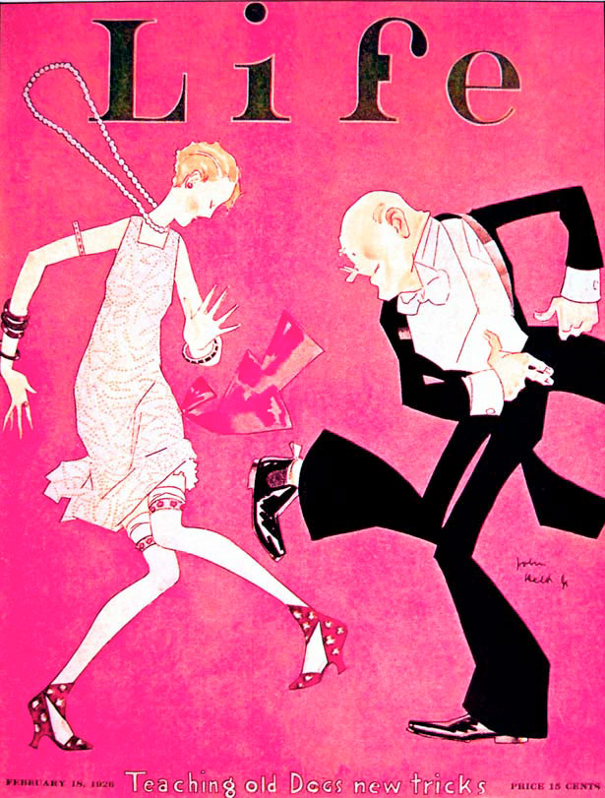

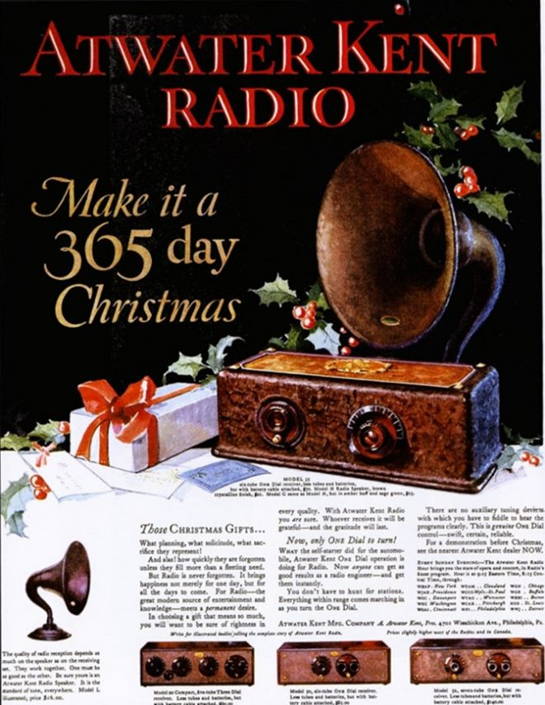



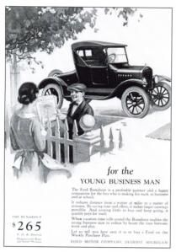

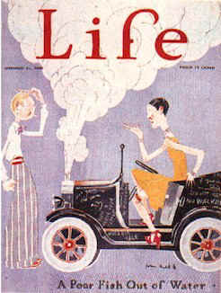



For each ad, answer:

1. What is being advertised?
   1. What’s the “new” thing?
   2. Who is in the ad? How are women shown?
2. How is it being advertised? Who is the target audience?

Overall,

1. Compare and contrast these ads to ones we’d see today.
2. What does these tell you about the culture of the 1920s? Give 3-5 specific items.